PLEASE FILL IN FORM AND SEND TO ADDRESS BELOW

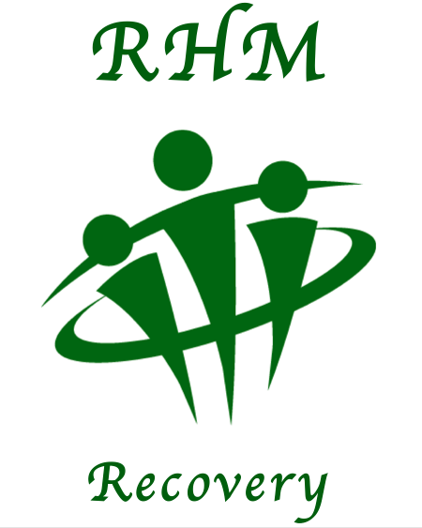
RHM Recovery
Selby Street
Hull
East Yorkshire
HU3 3PB

www.restoration-house-minist

Gift Aid Form
If you are a UK taxpayer and would like to Gift Aid your donations, increasing your gift by 20% at no cost to you, please sign the declaration below. That’s all there is to it!
Name:
Address:

Postcode:

Gift Aid declaration
I agree that RHM Recovery can treat this and all donations I make from January 2019 as Gift Aid Donations, until I notify you otherwise.
Signed: Date:

Note: 1. Gift Aid allows us to claim the tax you have already paid on your donations to RHM recovery, and will increase your donation by almost a third at no cost to you.
2. You must pay an amount of income tax (or capital gains tax) equal to the tax to be reclaimed on these donations. You may withdraw your declaration at any time, but only in respect of donations made after the date of cancellation. Please remember to tell us if you change your address, or if your tax situation changes. If you are not sure if you qualify for Gift Aid please contact us.

