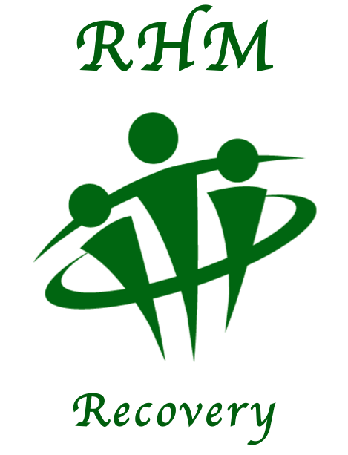

**RHM Recovery**

Head Office

Selby Street,

Hull,

East Yorkshire,

HU3 3PB.

**P A R T N E R S H I P F O R M**

|  |  |
| --- | --- |
| Name:  Address: | Bank Name:  Bank Address: |
|  |  |
| Account No, | Sort Code: |  |

Dear Bank Manager

Please pay the circled amount **every month** to account below, (circle as appropriate)

£10 £20 £30 £50 Other ___________

Starting on 1st __________________2020, until further notice.

Pay this sum to the account of ‘**Restoration House Ministries’** at **HSBC Bank, Bridlington.**

**Acc. No. 51287818 Sort Code: 40-24-31**

**SIGNED__________________________ DATE_________________**

 Please tick the box if you are a UK taxpayer and would like us to Gift Aid your donations, increasing your gift by 20% at no cost to you. If you wish to Gift Aid please sign the declaration below.

GIFT AID DECLARATION

I agree that Restoration House Ministries can treat this and all donations I make from November 2007 as Gift Aid donations, until I notify you otherwise.

SIGNED_____________________ DATE___________________

NOTES: You must pay an amount of income tax (or capital gains tax) equal to the tax to be reclaimed on these donations. You may withdraw your declaration at any time, but only in respect of donations made after the date of cancellation. Please remember to tell us if you change your address, or if your tax situation changes. If you are not sure if you qualify for Gift Aid, please contact your nearest tax office.

**Online Banking** details you require: **Account Name RHM** **Acc. No. 51287818 Sort Code: 40-24-31**